|  |  |
| --- | --- |
| Name : [Mike](mailto:johnvincentdallego082193@gmail.com) Leanard Cabacaba | Section : BSIT 3C |
| Assignment No : | Submission Date : March 16, 2024 |
| Assignment Title: Calculator | |

**Code :**

**HTML FILE**

*<!DOCTYPE html>*

*<html>*

*<head>*

*<title>Online Calculator</title>*

*<meta name="viewport" content="width=device-width, initial-scale=1.0">*

*<link rel="stylesheet" href="index.css">*

*</head>*

*<body>*

*<form name="form1">*

*<input class="textview" name="textview ">*

*</form>*

*<div class="format">*

*<table>*

*<tr>*

*<td><input class="btn bg-warning" type="button" value="+" onclick="input('+')"></td>*

*<td><input class="btn" type="button" value="7" onclick="input(7)"></td>*

*<td><input class="btn" type="button" value="8" onclick="input(8)"></td>*

*<td><input class="btn" type="button" value="9" onclick="input(9)"></td>*

*</tr>*

*<tr>*

*<td><input class="btn bg-warning" type="button" value="-" onclick="input('-')"></td>*

*<td><input class="btn" type="button" value="4" onclick="input(4)"></td>*

*<td><input class="btn" type="button" value="5" onclick="input(5)"></td>*

*<td><input class="btn" type="button" value="6" onclick="input(6)"></td>*

*</tr>*

*<tr>*

*<td><input class="btn bg-warning" type="button" value="*" onclick="input('*')"></td>*

*<td><input class="btn" type="button" value="1" onclick="input(1)"></td>*

*<td><input class="btn" type="button" value="2" onclick="input(2)"></td>*

*<td><input class="btn" type="button" value="3" onclick="input(3)"></td>*

*</tr>*

*<tr>*

*<td><input class="btn bg-warning" type="button" value="/" onclick="input('/')"></td>*

*<td><input class="btn" type="button" value="0" onclick="input(0)"></td>*

*<td><input class="btn" type="button" value="." onclick="input('.')"></td>*

*<td><input class="btn" type="button" value="=" onclick="equal()"></td>*

*</tr>*

*<tr>*

*<td><input class="btn bg-warning" type="button" value="c" onclick="form1.textview.value=' '"></td>*

*</tr>*

*</table>*

*</div>*

*</body>*

*<script src="index.js"></script>*

*</html>*

**JS FILE**

*function input(num)*

*{*

*form1.textview.value= form1.textview.value + num;*

*}*

*function equal()*

*{*

*var total = form1.textview.value;*

*if(total)*

*{*

*form1.textview.value = eval(total);*

*}*

*}***CSS FILE**

*/*Calculator Layot */*

*.format{*

*width: 268px;*

*height: 330px;*

*margin:auto;*

*padding:5px;*

*border: none;*

*text-align: center;*

*background-color: #262626;*

*}*

*\*{*

*margin: 0;*

*padding: 0;*

*}*

*body{*

*padding:60px;*

*}*

*/*Interaction design */*

*input:hover*

*{*

*background-color: gray;*

*color:white;*

*border:none;*

*}*

*form{*

*text-align: center;*

*margin:auto;*

*}*

*.textview{*

*width: 262px;*

*height: 50px;*

*border-radius: 5px 5px 0 0;*

*padding:8px;*

*color:white;*

*background-color:#595959;*

*border:none;*

*outline: none;*

*font-size: 30px;*

*}*

*/*Button design */*

*.btn{*

*width:60px;*

*height:60px;*

*border-radius: 50%;*

*cursor: pointer;*

*border:none;*

*margin:2px;*

*color:white;*

*background-color:#595959;*

*font-size: 30px;*

*}*

*.bg-warning{*

*background-color:orange;*

*}*

*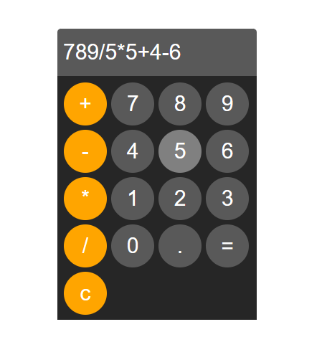***SCREENSHOT**

*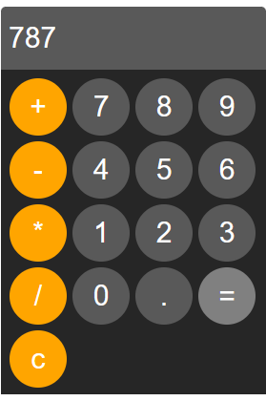***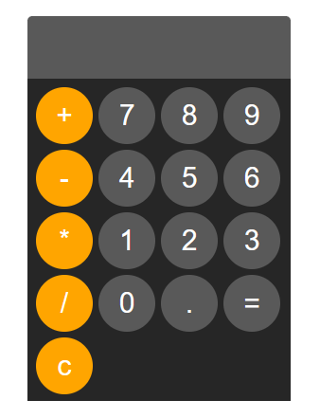**

**Dictionary:***:*

* **<td>** - is a tag that a cell within a table row.

**Syntax** : <td>row, cell</td>

**Parameter** : none

* **<div>** - stands for "division" or "divider," indicating its purpose to divide or group content   
  within a web page.

**Syntax** : <div class="format">

Contents…

</div>

**Parameter** : class=”format”

* **input(num)** – is a function that allows users to input numerical values by clicking the buttons, or doing specified events.

**Syntax** : function input(num) {

form1.textview.value = form1.textview.value + num;

}

**Parameter:** num(float,int,string,variable)

console.log(input(5))

output: 5;

* **:hover** - selector is used to select elements when you mouse over them.

**Syntax** : input:hover

**Parameters**: none.

* **var** - the keyword that tells JavaScript you're declaring a variable

**Syntax** : var total = = form1.textview.value

**Parameters:**none;

console.log(var(5+5))

Output: 10